Alec Haws

CIT 230

Brother Cheney

2.1.2018

**Site Name**: GonnaRain? ([www.gonnarain.com](http://www.gonnarain.com) is currently an available domain)

**Site Purpose**: The purpose of GonnaRain is to provide users with accurate real-time information about the weather in their local community. We do this by providing current weather reports, forecasts (hourly, daily, and weekly), and by providing relevant news stories as well.

**Target Audience:**

1. **Scenario 1:** A college-age student who is fairly confident online, and is coming home for the weekend. They could use the website to check what the weather will be like during their visit. The site can also provide them with some local news relating to the climate.
2. **Persona 2:** An early thirty’s man that has lived in Preston, ID how whole life. He is not entirely comfortable in using a computer, but the website presents him with the information that he needs in a short amount of time. He is able to open the page and see the forecast for his town within a single click.
3. **Persona 3:** An elderly person that does not use computers much at all. They are wanting to visit a friend in Soda Springs, but they do not like driving in the snow. They are able to easily navigate the website on their iPad. The user interface uses contrast that makes the text easy to read. The font is also good for smaller screens, so they are able to find the information that they need with ease.
4. **Persona 4:** A tourist will be visiting several towns in Idaho and wants to get some information about the weather for the towns that they plan on visiting. They also want to know what is going on in the town, so they appreciate the local news section too.
5. **Persona 5:** A local mom lives in Soda Springs, but she needs to take her kids to soccer practice a couple of towns away in Preston. She uses the site to see what the weather is like in the two towns, and also to know if there are any storms to watch out for on the drive between the two.

**Site Map:**

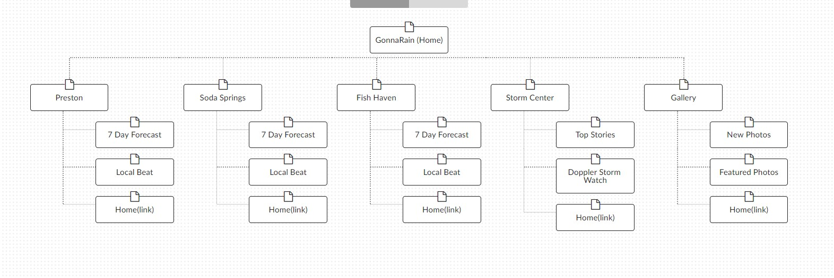

Color Palette and Fonts



|  |  |  |  |  |
| --- | --- | --- | --- | --- |
| **Attribute** | **Font** | **Size** | **Color Palette** | **Sample** |
| Header | Roboto | 1.75rem | **Background:**  #6965db  **Text:**  #ffa62f | Sample |
| Navigation | Roboto | .9rem | **Background:**  #648af2  **Text:**  #ffd296 | Sample |
| Footer | Roboto | 1rem | **Background:**  #6965db  **Text:**  #ffa62f | Sample |
| Heading 1 (h1) | Roboto | 2rem | #6ff9e0 | Sample |
| Heading 2 (h2) | Roboto | 1.5rem | #6ff9e0 | Sample |
| Heading 3 (h3) | Roboto | .8rem | #6ff9e0 | Sample |
| Paragraph (p) | Monserrat | 1rem | #000000 | Sample |